Replace and modernize legacy VPN architectures with a cloud-native Zscaler Zero Trust solution

Replace and modernize legacy VPN architectures with a cloud-native Zscaler Zero Trust solution

S.NO. | Name | College Name | Contact
1 | Dakshata . R | Sri Ramakrishna College of Arts and Science for Women | srcw2322k104@srcw.ac.in
2 | Nandhini . D | Sri Ramakrishna College of Arts and Science for Women | srcw2322k133@srcw.ac.in
3 | Nandhini . P | Sri Ramakrishna College of Arts and Science for Women | srcw2322k134@srcw.ac.in
4 | Nivetha . S A | Sri Ramakrishna College of Arts and Science for Women | srcw2322136@srcw.ac.in

Project Details

Title : Replace and modernize legacy VPN architectures with a cloud-native Zscaler Zero Trust solution

In today’s digital world, organizations are rapidly adopting cloud services, remote work models, and mobile devices to improve productivity and business efficiency. Traditional network security models were designed when most users and applications were located inside a corporate network. These models rely heavily on perimeter-based security and Virtual Private Networks (VPNs) to provide remote access to internal resources. However, as organizations continue to move applications to the cloud and employees increasingly work from remote locations, legacy VPN architectures are becoming less effective, complex to manage, and vulnerable to cyber threats.
Legacy VPN solutions were originally designed to allow remote users to securely connect to an organization’s internal network through encrypted tunnels. While VPNs provide secure connectivity, they also create several challenges. One of the major issues with VPNs is that once a user gains access to the network, they may have broader access than necessary. This increases the risk of unauthorized access and lateral movement if the user’s device is compromised. Additionally, VPN infrastructures often require expensive hardware, complex configuration, continuous maintenance, and can lead to performance issues due to network congestion or backhauling of traffic through centralized data centers.
As modern enterprises move towards cloud computing and distributed work environments, the need for a more secure, scalable, and flexible network security model has become essential. This is where the Zero Trust security model comes into play. The Zero Trust approach is based on the principle of “never trust, always verify.” Instead of automatically trusting users inside a corporate network, Zero Trust continuously verifies the identity, device posture, and context of every user attempting to access an application or resource. Access is granted only after proper authentication and authorization, ensuring that users can only reach the applications they are permitted to use.
Zscaler provides a cloud-native Zero Trust platform that helps organizations replace traditional VPN architectures with a modern and secure access solution. Unlike legacy VPNs, Zscaler’s Zero Trust architecture does not expose applications directly to the internet. Instead, it creates a secure connection between users and applications without placing the user on the corporate network. This significantly reduces the attack surface and prevents unauthorized access to internal systems.
One of the key components of Zscaler’s Zero Trust solution is Zscaler Private Access (ZPA), which enables secure access to internal applications without the need for a VPN. ZPA connects users directly to specific applications rather than giving them access to the entire network. This ensures that users only have access to the resources they need, thereby improving security and reducing potential risks. In addition, Zscaler’s cloud-based architecture eliminates the need for traditional hardware appliances and provides seamless scalability as organizations grow.
Another important advantage of adopting a cloud-native Zero Trust model is improved user experience and performance. Traditional VPN solutions often require users to route their traffic through centralized gateways, which can lead to slow connections and network bottlenecks. Zscaler’s distributed cloud platform allows users to connect to the nearest Zscaler data center, reducing latency and improving application performance. This approach ensures secure access regardless of the user’s location, device, or network.
Furthermore, modern Zero Trust solutions offer enhanced visibility and control over network traffic and user activities. Organizations can monitor access requests, enforce security policies, and detect suspicious behavior in real time. This helps security teams respond quickly to potential threats and maintain a strong security posture.
In conclusion, as organizations continue to embrace cloud technologies and remote work environments, traditional VPN architectures are no longer sufficient to meet modern security requirements. Replacing legacy VPN systems with a cloud-native Zero Trust solution such as Zscaler provides stronger security, better scalability, improved performance, and simplified management. By adopting a Zero Trust model, organizations can protect their applications and data while enabling secure and efficient access for users anywhere in the world.

Abstract :
With the rapid growth of cloud computing, mobile devices, and remote work environments, traditional network security methods are becoming less effective in protecting organizational resources. Legacy Virtual Private Network (VPN) architectures were originally designed to provide secure remote access to users connecting from outside the corporate network. However, these traditional VPN solutions often expose the internal network to potential security risks, increase operational complexity, and create performance challenges. As organizations increasingly adopt cloud-based applications and distributed workforces, there is a strong need to modernize network security by moving beyond traditional perimeter-based security models.
The Zero Trust security model has emerged as a modern approach to address these challenges. Zero Trust operates on the principle of “never trust, always verify,” where every user, device, and application request is continuously authenticated and authorized before access is granted. Instead of providing broad network access like traditional VPNs, Zero Trust ensures that users are only allowed to access the specific applications and resources they are authorized to use. This approach significantly reduces the attack surface and helps prevent unauthorized access and lateral movement within the network.
Zscaler provides a cloud-native Zero Trust platform designed to replace legacy VPN architectures with a more secure and scalable access solution. Through services such as Zscaler Private Access (ZPA), users can securely connect to internal applications without being directly connected to the corporate network. This architecture hides applications from the public internet and ensures that access is granted only after proper identity verification and policy enforcement. By eliminating the need for traditional VPN hardware and network backhauling, Zscaler simplifies security management and improves network performance.
In addition to improved security, the cloud-native architecture of Zscaler provides better scalability and flexibility for modern enterprises. Users can securely access applications from any location, device, or network while maintaining strong security controls. The distributed cloud infrastructure also reduces latency by allowing users to connect through the nearest Zscaler data center, resulting in a faster and more reliable user experience.

Use Case Scenarios :
Scenario 1 : Secure Remote Employee Access

An employee working from home needs to access internal company applications such as HR systems or project management tools. In traditional VPN architecture, the employee must connect to the corporate network first, which may cause network congestion and security risks.

Output :

- Secure authentication of the employee is verified.
- Access is provided only to the required application.
- No full network access is given to the user.
- Faster and safer remote connectivity is achieved.

Scenario 2 : Third-Party Vendor Access Control
An external vendor needs limited access to maintain a specific internal application.

Output :

- Vendor identity is verified before granting access.
- Access is restricted only to the authorized application.
- Internal network resources remain protected.

Scenario 3 : Secure Access for Mobile Users
Employees access company resources using laptops or mobile devices from different locations.
Output :
- Secure connection is established through Zscaler Client Connector.
- Access is granted based on user identity and device security.
- Users can access applications from any location.

Scenario 4 : Protection Against Unauthorized Access
A compromised or untrusted device tries to access internal applications.
Output :
- Device security status is checked.
- Unauthorized or unsafe devices are blocked.
- Sensitive company data is protected.

Scenario 5 : Secure Cloud Application Access
Employees need to access applications hosted in the cloud.
Output :
- User identity and access policies are verified.

Stage - 1

Title Of the Project :-

Replace and modernize legacy VPN architectures with a cloud-native Zscaler Zero Trust solution

Overview :-

Legacy Virtual Private Network (VPN) architectures have historically been one of the most widely used technologies for enabling secure remote connectivity between users and organizational networks. For many years, VPNs served as a reliable solution that allowed employees, partners, and administrators to securely access corporate resources from outside the office environment. By creating encrypted communication tunnels over public networks such as the internet, VPN technology ensured that sensitive information transmitted between users and corporate infrastructure remained protected from interception or unauthorized access.
In traditional enterprise environments, where most applications were hosted inside centralized corporate data centers and employees primarily worked within office networks, VPN solutions provided a convenient and relatively secure way to extend internal network access to remote users. Employees traveling for business, working from home, or accessing systems from branch offices could connect through a VPN gateway and interact with internal applications just as if they were physically present inside the organization's network.
However, while VPN systems were originally designed for earlier IT architectures, the modern digital environment has evolved significantly. Organizations today rely heavily on cloud computing, distributed infrastructures, mobile devices, and hybrid work environments. Applications are no longer limited to internal data centers but are increasingly hosted on cloud platforms and Software-as-a-Service (SaaS) environments. At the same time, the number of remote users accessing enterprise resources has grown dramatically due to the rise of remote work and global collaboration.
As a result of these changes, traditional VPN architectures are now facing serious security, scalability, and operational limitations. Although VPNs provide encrypted connectivity, they were designed around the concept of trusted internal networks, which no longer aligns with modern cybersecurity principles. Attackers have also become more sophisticated, using advanced techniques such as credential theft, lateral movement, malware infiltration, and network reconnaissance to exploit weaknesses in traditional network security models.
Understanding the vulnerabilities associated with legacy VPN systems is therefore critical for organizations seeking to modernize their cybersecurity infrastructure. By examining the weaknesses of traditional VPN architectures, organizations can better understand why modern security models such as Zero Trust architecture are becoming essential. Platforms like Zscaler Zero Trust Exchange have emerged as powerful solutions designed to overcome the limitations of legacy VPN systems while providing stronger security controls and improved operational efficiency.
One of the most critical vulnerabilities of traditional VPN systems is the issue of excessive network access. In many legacy VPN deployments, once a user successfully authenticates to the VPN gateway, they are granted access to large portions of the internal network rather than only the specific applications or services required for their job role. This design is based on the assumption that users who successfully authenticate are trustworthy and should be treated as internal network users.
However, this assumption creates a significant security risk. If an attacker gains access to a user's credentials through methods such as phishing attacks, password theft, or credential reuse, the attacker can authenticate to the VPN just like a legitimate employee. Once connected, the attacker may be able to explore the internal network, identify vulnerable systems, and move laterally between servers and devices. This process, known as lateral movement, allows attackers to expand their access within the network and potentially compromise critical systems such as databases, file servers, and authentication services. In large organizations, this type of attack can lead to severe consequences including data breaches, intellectual property theft, operational disruption, and financial loss.
Another major vulnerability associated with legacy VPN architectures is the exposure of VPN gateways to the public internet. In order to allow remote connectivity, organizations must deploy VPN gateways that are accessible from external networks. These gateways act as entry points to the internal corporate network and therefore become highly attractive targets for cyber attackers.
Attackers frequently scan the internet for exposed VPN gateways and attempt to exploit them using various attack techniques. These may include brute-force password attacks, credential stuffing, exploitation of software vulnerabilities, denial-of-service attacks, or attempts to bypass authentication mechanisms. If the VPN gateway software is not regularly updated or if it contains security vulnerabilities, attackers may be able to compromise the gateway itself. Once the gateway is compromised, attackers can gain unauthorized access to the corporate network, potentially bypassing multiple layers of security protection.
Credential-based attacks represent another serious challenge in traditional VPN environments. Many organizations rely primarily on username and password authentication for VPN access. Although some organizations implement additional security measures such as multi-factor authentication, many legacy deployments still rely on weak authentication practices. Attackers frequently exploit these weaknesses by launching phishing campaigns to trick users into revealing their credentials or by using previously leaked passwords from other websites.
Once attackers obtain valid login credentials, they can authenticate to the VPN network without raising immediate suspicion. Because the connection appears legitimate, security monitoring systems may not detect the malicious activity until significant damage has already occurred. In some cases, attackers may remain undetected within the network for long periods of time while gathering information, escalating privileges, and preparing for larger attacks such as ransomware deployment or data exfiltration.
Beyond security vulnerabilities, traditional VPN architectures also introduce several performance and scalability challenges. VPN systems typically rely on centralized hardware appliances that are installed within corporate data centers. These appliances are responsible for managing encrypted connections, authenticating users, and routing traffic between remote users and internal resources. When only a small number of employees require remote access, this model works reasonably well.
However, modern organizations often support thousands of remote users simultaneously. During large-scale remote work events, such as those experienced during global disruptions or rapid business expansion, VPN gateways may struggle to handle the increased number of connections. As the number of users grows, VPN servers may become overloaded, resulting in slow connections, network congestion, and degraded application performance. This can significantly impact employee productivity and create frustration among users who rely on remote connectivity to perform their work.
Another major operational challenge associated with VPN systems is traffic backhauling. In many traditional network architectures, all user traffic must first pass through the corporate data center before reaching external cloud services. For example, when a remote employee accesses a cloud-based application such as Microsoft 365, the data may travel from the user's device to the corporate VPN gateway, then through the organization's internal network, and finally out to the cloud service.
This indirect routing method increases network latency and consumes additional bandwidth. Instead of accessing cloud services directly through optimized internet paths, users experience slower performance due to the extra network hops required. As organizations continue to adopt cloud services and SaaS applications, traffic backhauling becomes increasingly inefficient and costly.
Another significant limitation of traditional VPN systems is the lack of detailed visibility and monitoring capabilities. While VPN solutions typically generate basic connection logs, they often do not provide comprehensive insight into user behavior or application usage. Security teams may know when a user connects to the VPN, but they may not have detailed information about which applications the user accessed, how long the session lasted, or whether sensitive data was transferred during the session.
This lack of visibility makes it difficult for security teams to identify abnormal user behavior or detect potential security incidents in real time. For example, if a compromised user account suddenly begins accessing large amounts of sensitive data or connecting from unusual geographic locations, traditional VPN systems may not provide sufficient monitoring capabilities to detect the threat quickly.
Another important risk associated with legacy VPN environments involves device security posture. VPN systems typically authenticate the user but may not verify whether the device being used meets security requirements. A device that lacks security patches, antivirus protection, or endpoint security software may still be able to connect to the VPN network if the user provides valid credentials.
If such a device is infected with malware or ransomware, it can introduce malicious activity directly into the internal network once connected through the VPN. This creates opportunities for attackers to spread malware, steal sensitive information, or disrupt business operations. Modern cybersecurity strategies therefore emphasize the importance of verifying both user identity and device health before granting access to enterprise resources.
Additionally, legacy VPN infrastructures often require complex maintenance and management. Organizations must deploy and maintain multiple hardware appliances, configure firewall rules, update VPN software, and manage network routing configurations. These tasks require significant effort from IT administrators and can introduce potential security risks if not managed properly.
Misconfigured VPN settings, outdated software, or improperly maintained hardware can create vulnerabilities that attackers may exploit. As organizations expand their networks and deploy more applications across different environments, managing traditional VPN infrastructure becomes increasingly complicated and costly.
Due to these limitations and vulnerabilities, many organizations are transitioning toward modern security frameworks based on the Zero Trust security model. The Zero Trust approach fundamentally changes the way network access is granted by eliminating the assumption that users inside the network are automatically trusted.
Instead, Zero Trust follows the principle of “Never Trust, Always Verify.” Every access request must be authenticated, authorized, and continuously validated before access is granted to an application or resource. This model ensures that users only receive access to the specific applications they need, rather than gaining broad network-level access.
Cloud-native security platforms such as Zscaler Zero Trust Exchange implement this architecture by eliminating traditional VPN connections altogether. Instead of connecting users directly to the corporate network, Zscaler acts as a secure intermediary that connects users to specific applications through controlled and authenticated connections. Internal applications remain hidden from the public internet, significantly reducing the attack surface and preventing attackers from discovering or targeting internal systems.
By implementing Zero Trust security through platforms like Zscaler, organizations can achieve improved security, enhanced visibility, better scalability, and simplified network management. The cloud-native architecture also eliminates traffic backhauling and allows users to connect to applications through the nearest secure access point, improving performance and user experience.
In conclusion, while legacy VPN architectures played an important role in enabling secure remote connectivity in earlier IT environments, they are no longer sufficient to address the complex cybersecurity challenges faced by modern organizations. The rapid growth of cloud computing, remote work, and sophisticated cyber threats has exposed critical weaknesses in traditional VPN systems. Transitioning to a Zero Trust security architecture powered by cloud-native platforms such as Zscaler enables organizations to modernize their security infrastructure, reduce vulnerabilities, and provide secure access to applications in an increasingly distributed digital world.

Replace and modernize legacy VPN architectures with a cloud-native Zscaler Zero Trust solution

List of Team members:

S.NO. | Name | College Name | Contact
1 | Dakshata . R | Sri Ramakrishna College of Arts and Science for Women | srcw2322k104@srcw.ac.in
2 | Nandhini . D | Sri Ramakrishna College of Arts and Science for Women | srcw2322k133@srcw.ac.in
3 | Nandhini . P | Sri Ramakrishna College of Arts and Science for Women | srcw2322k134@srcw.ac.in
4 | Nivetha . S A | Sri Ramakrishna College of Arts and Science for Women | srcw2322136@srcw.ac.in

List of Vulnerability Table :

S.no | Category Name | Vulnerability Name | CWE - No
1 | Broken Access Control | Storage of File with Sensitive Data Under Web Root | CWE-219
2 | Security Misconfiguration | Exposure of Sensitive Information Through Environmental Variables | CWE-526
3 | Software Supply Chain Failures | Improper Neutralization of Alternate XSS Syntax | CWE-87
4 | Cryptographic Failures | Missing Required Cryptographic Step | CWE-325
5 | Injection | Improper Neutralization of Invalid Characters in Identifiers in Web Pages | CWE-86
6 | Insecure Design | Cleartext Storage in a File or on Disk | CWE-313
7 | Authentication Failures | Authentication Bypass by Capture-replay | CWE-294
8 | Software or Data Integrity Failures | Reliance on Cookies without Validation and Integrity Checking | CWE-565
9 | Security Logging & Alerting Failures | Improper Output Neutralization for Logs | CWE-117
10 | Mishandling of Exceptional Conditions | Divide By Zero | CWE-369

REPORT
1.
Vulnerability Name: Storage of File with Sensitive Data Under Web Root
CWE: CWE - 219
OWASP Category : A01 Broken Access Control
Description: Storing files that contain sensitive data under the web root directory is a security vulnerability in web applications. The web root is the main folder from which a web server (such as Apache, Nginx, or IIS) serves files to users through a browser. Any file placed inside this directory can potentially be accessed directly through a URL.
When sensitive files such as configuration files, backup files, database dumps, user information, passwords, API keys, or system logs are stored inside the web root, attackers may be able to access them if they know or guess the file path. This can lead to data leakage, unauthorized access, or complete compromise of the system.
To prevent this issue, sensitive files should be stored outside the web root directory so that they cannot be accessed directly through the web server. Additionally, developers should implement proper access controls, file permissions, and secure configuration practices to protect confidential information.
In summary, storing sensitive files under the web root can expose critical data to attackers, making it important to follow secure storage practices to protect application and user data.
Business impact: Storing sensitive files under the web root can create serious risks for an organization. If attackers access these files, it can lead to multiple business impacts such as data breaches, financial loss, and damage to the organization’s reputation.
- Data Breach
Sensitive information such as user details, passwords, database credentials, or internal configuration files may be exposed. This can allow attackers to steal confidential data.
- Unauthorized System Access
If configuration files or database credentials are exposed, attackers may gain access to the application server or database. This can allow them to modify, delete, or misuse important data.
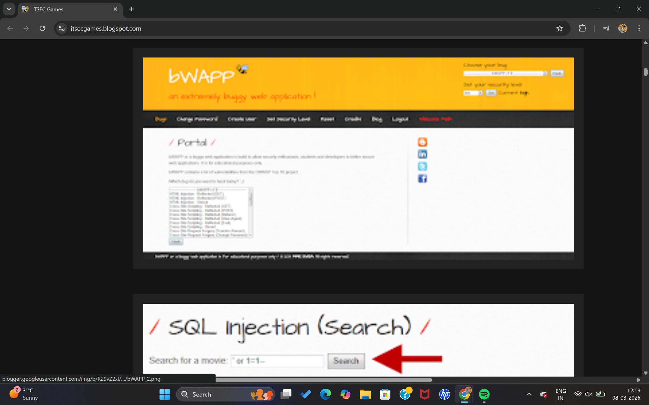

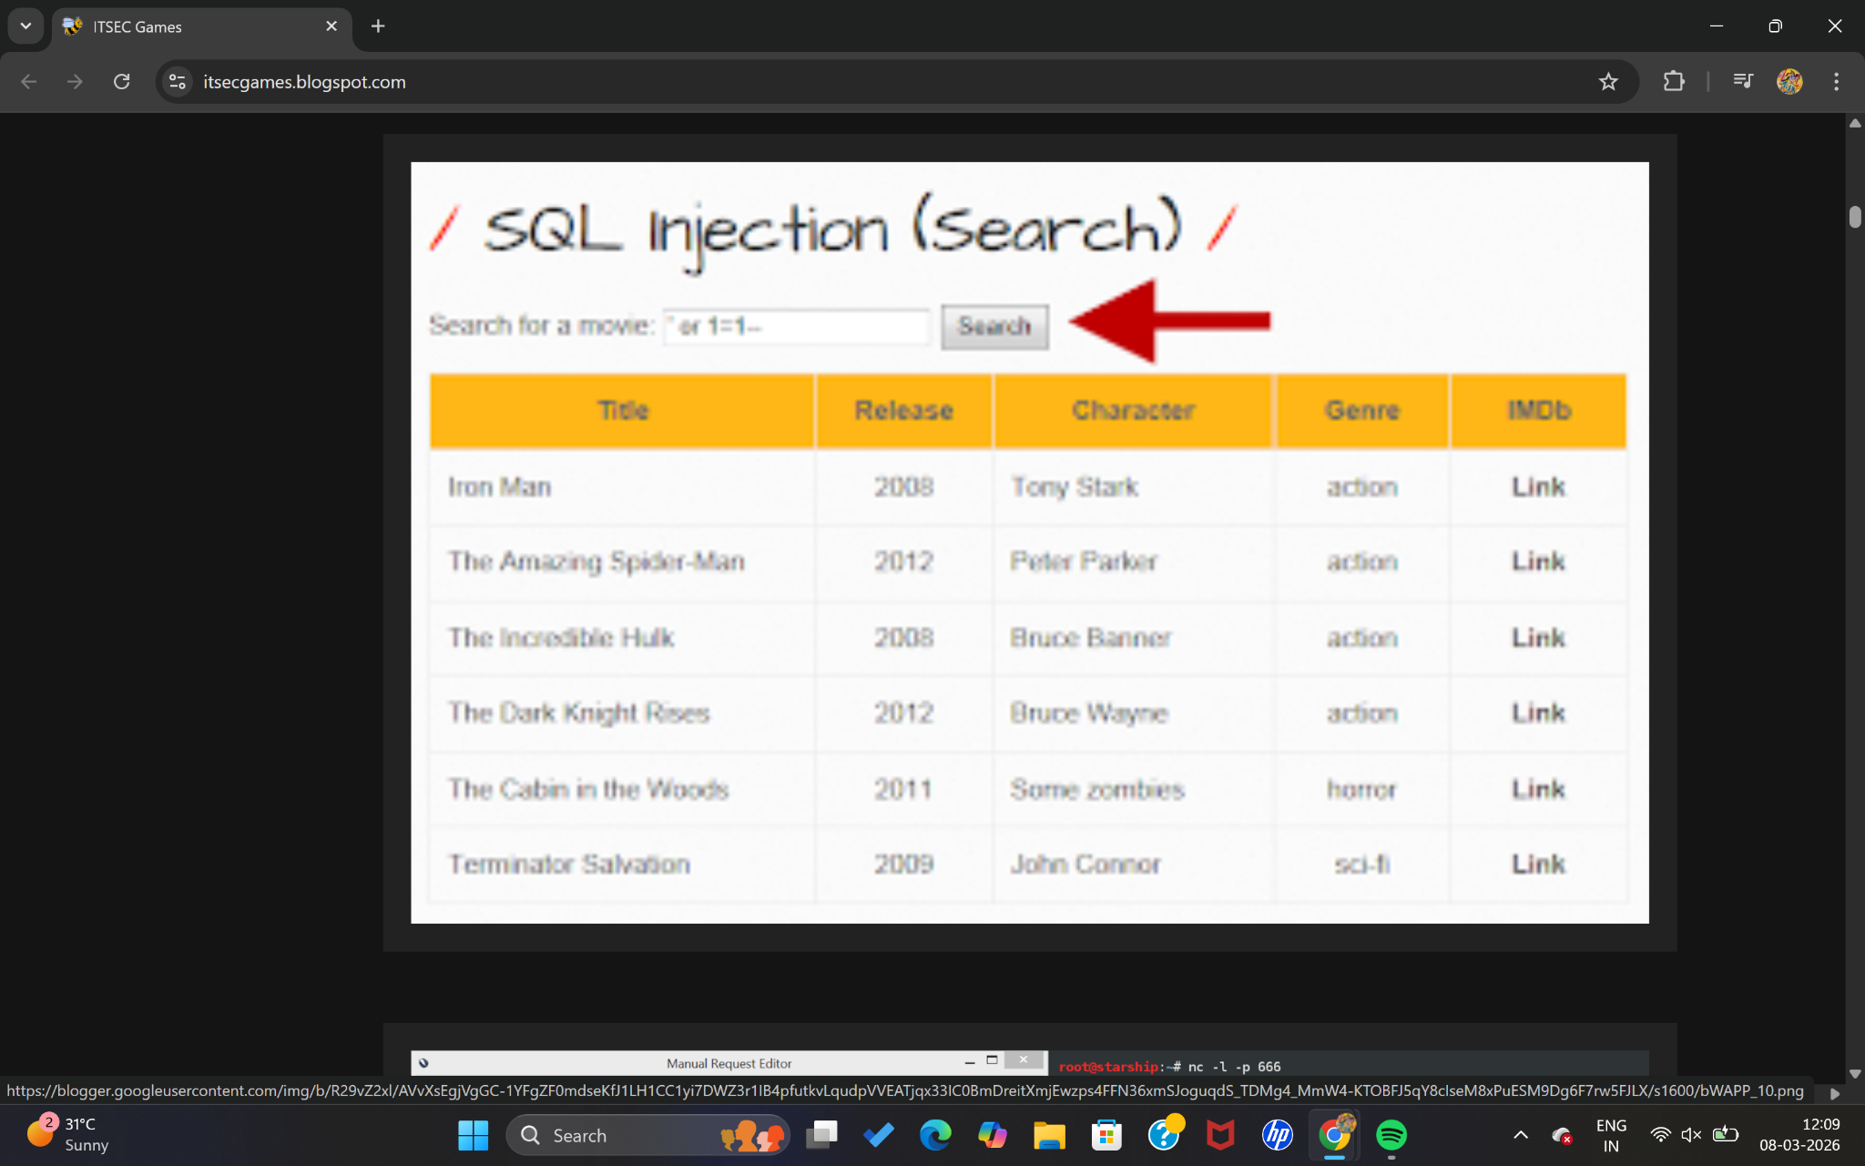

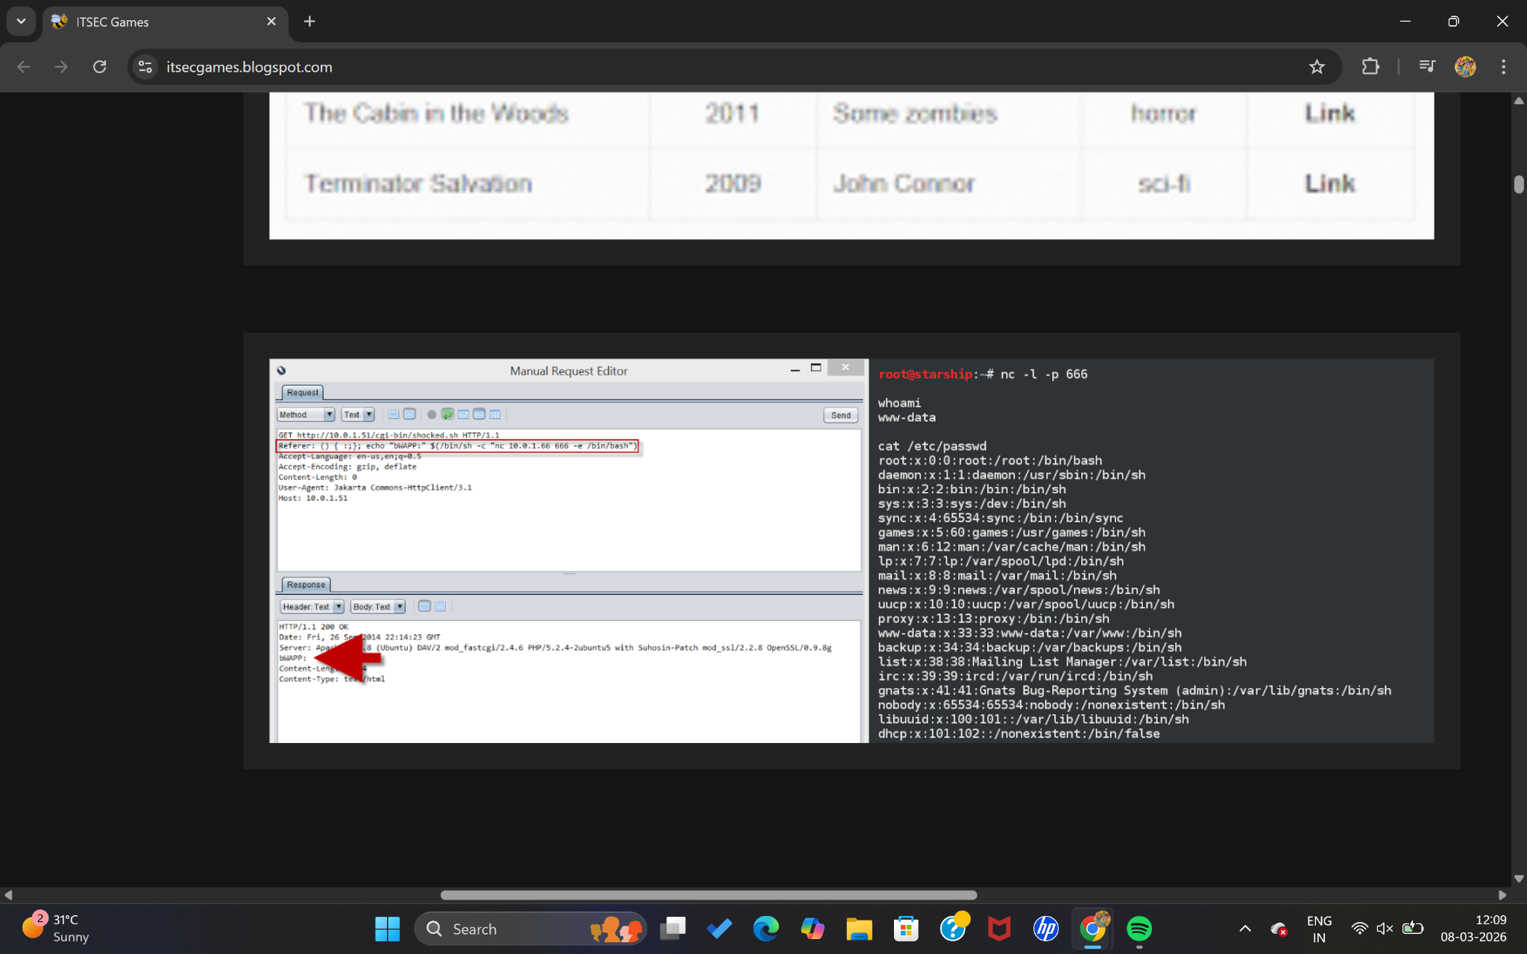

2) Vulnerability Name: Exposure of Sensitive Information Through Environmental Variables
CWE: CWE – 526
OWASP Category: A05:2021 – Security Misconfiguration

Description
Environmental variables are commonly used to store configuration information such as database credentials, API keys, encryption secrets, and system settings. These variables help applications manage sensitive configuration without hardcoding them into the source code.
However, when environmental variables are improperly exposed through debugging tools, application logs, error messages, or public endpoints, attackers may gain access to sensitive information.
For example, if a server misconfiguration exposes environment variables through an error page or API response, attackers could retrieve database passwords or authentication tokens.
This vulnerability typically occurs due to poor configuration practices or insecure development environments.
To prevent this issue, developers should ensure that environment variables are not exposed in application responses, logs, or debugging output. Proper access restrictions and secure configuration management should also be implemented.

Business Impact
Exposure of Sensitive Credentials
Attackers may obtain database passwords, API tokens, or encryption keys.
Unauthorized Access to Systems
With exposed credentials, attackers may gain access to databases or backend services.
Service Compromise
Sensitive configuration exposure can allow attackers to manipulate application behavior.
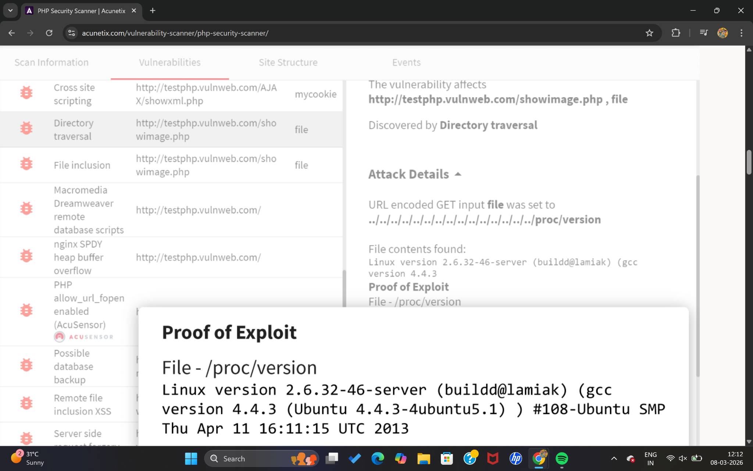

4) Vulnerability Name: Missing Required Cryptographic Step
CWE: CWE – 325
OWASP Category: A02:2021 – Cryptographic Failures

Description
Missing required cryptographic steps occur when an application fails to properly implement necessary encryption or security processes while handling sensitive information.
Cryptography is used to protect confidential data such as passwords, personal information, payment details, and authentication tokens. If an application skips important steps such as encryption, key validation, certificate verification, or integrity checking, sensitive information may become exposed.
For example, transmitting login credentials without encryption or failing to verify digital signatures can allow attackers to intercept or manipulate data.
This vulnerability usually occurs due to improper implementation of encryption libraries or misunderstanding of cryptographic protocols.
To mitigate this issue, developers should follow established cryptographic standards, enforce secure encryption protocols such as TLS, and ensure that all required cryptographic processes are properly implemented.

Business Impact
Sensitive Data Exposure
Unprotected data may be intercepted by attackers during transmission.
Financial Loss
Compromised financial information may lead to fraud or financial theft.
Regulatory Violations
Failure to protect sensitive data may result in legal penalties under data protection laws.
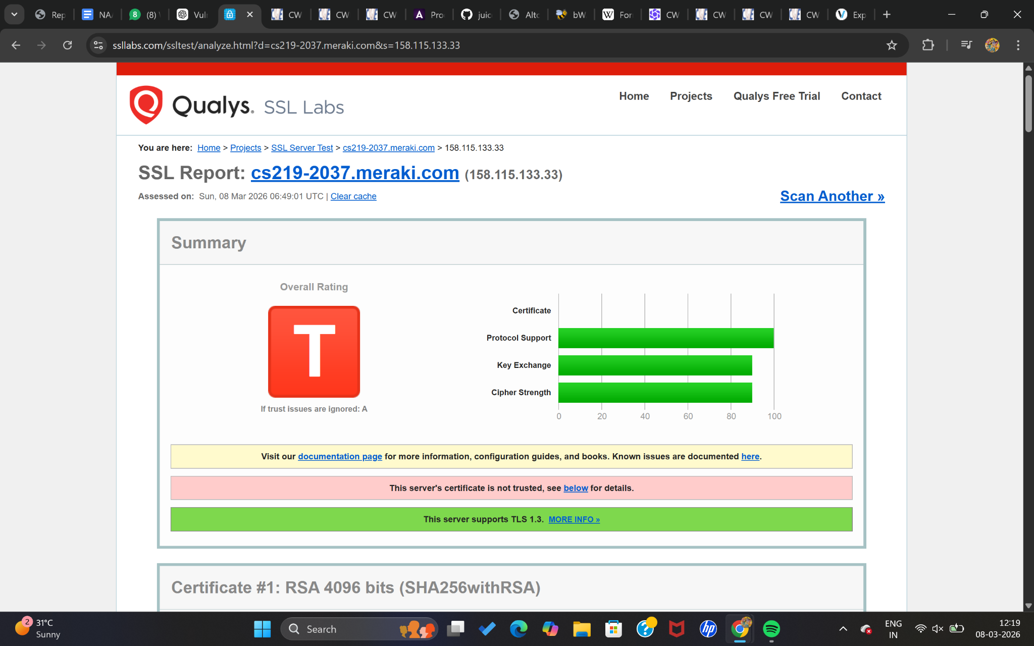
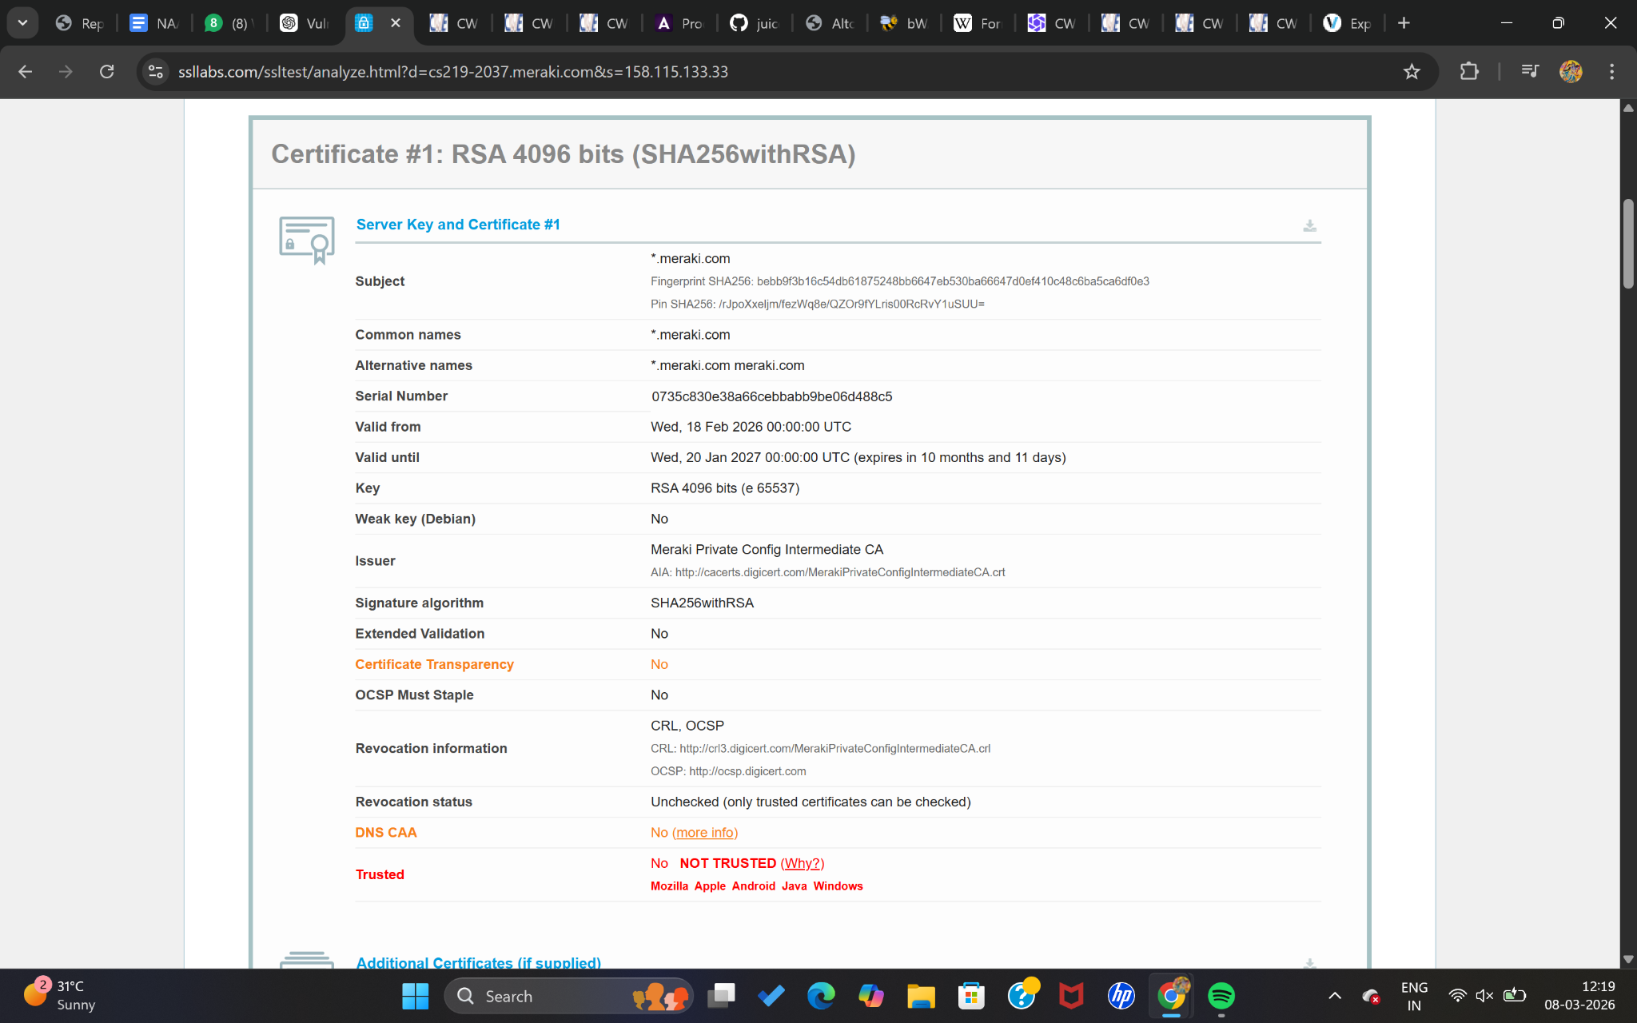

5) Vulnerability Name: Improper Neutralization of Invalid Characters in Identifiers in Web Pages
CWE: CWE – 86
OWASP Category: A03:2021 – Injection

Description
Improper neutralization of invalid characters occurs when a web application fails to properly validate or sanitize input that is used as identifiers in web pages.
Attackers may insert malicious characters or scripts into input fields such as usernames, form inputs, URL parameters, or search queries. If the application does not properly sanitize this input, it may lead to injection attacks.
For example, attackers may inject malicious code into identifiers used in HTML elements, database queries, or system commands. This can result in unauthorized actions or execution of harmful code.
Developers should implement strong input validation, output encoding, and secure coding practices to ensure that user input does not introduce malicious content into the application.

Business Impact
Execution of Malicious Code
Attackers may execute unauthorized commands on the system.
Data Manipulation
Attackers may alter or delete application data.
Website Defacement
Malicious code may modify web page content or redirect users to harmful websites.
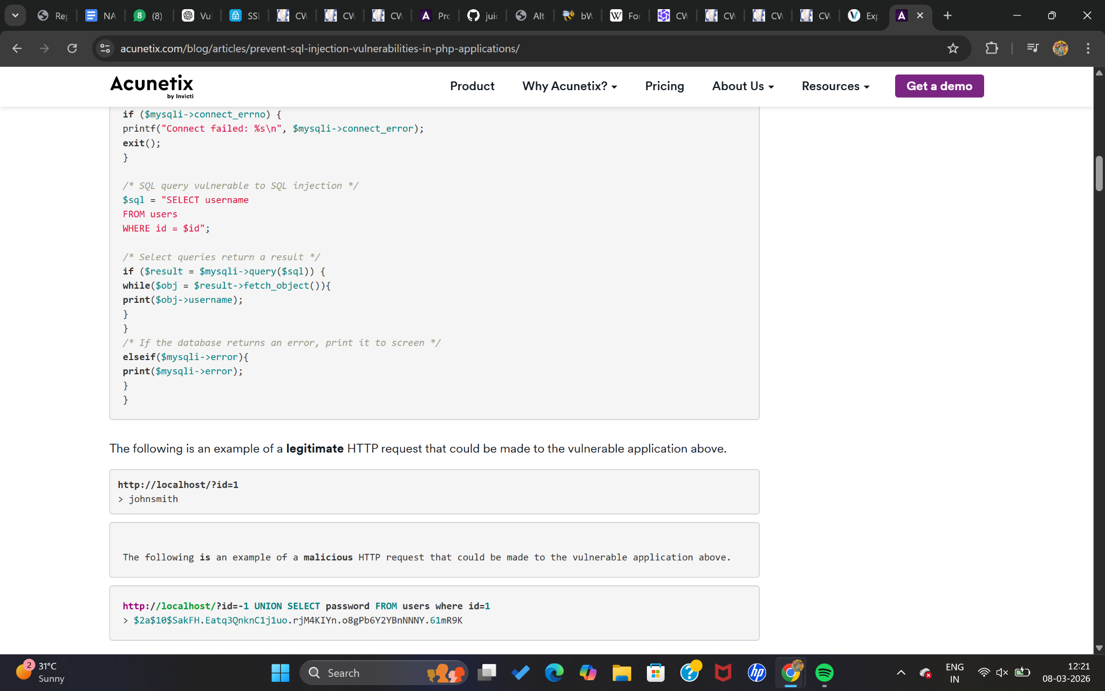

6) Vulnerability Name: Cleartext Storage in a File or on Disk
CWE: CWE – 313
OWASP Category: A04:2021 – Insecure Design

Description
Cleartext storage in a file or on disk occurs when sensitive information is stored without encryption or protection.
Sensitive data such as passwords, authentication tokens, personal information, and encryption keys should always be stored securely using encryption or hashing techniques.
If such information is stored in plain text files or system storage, attackers who gain access to the system can easily read and misuse the data.
This vulnerability may occur in configuration files, log files, backup files, or local storage where developers store sensitive information without proper protection.
To prevent this issue, organizations should encrypt sensitive data at rest, restrict file permissions, and use secure credential storage mechanisms.

Business Impact
Exposure of Confidential Data
Sensitive data can be accessed easily by attackers.
Identity Theft
User credentials stored in cleartext may be stolen and misused.
Compliance Violations
Organizations may fail to meet regulatory requirements for data protection.

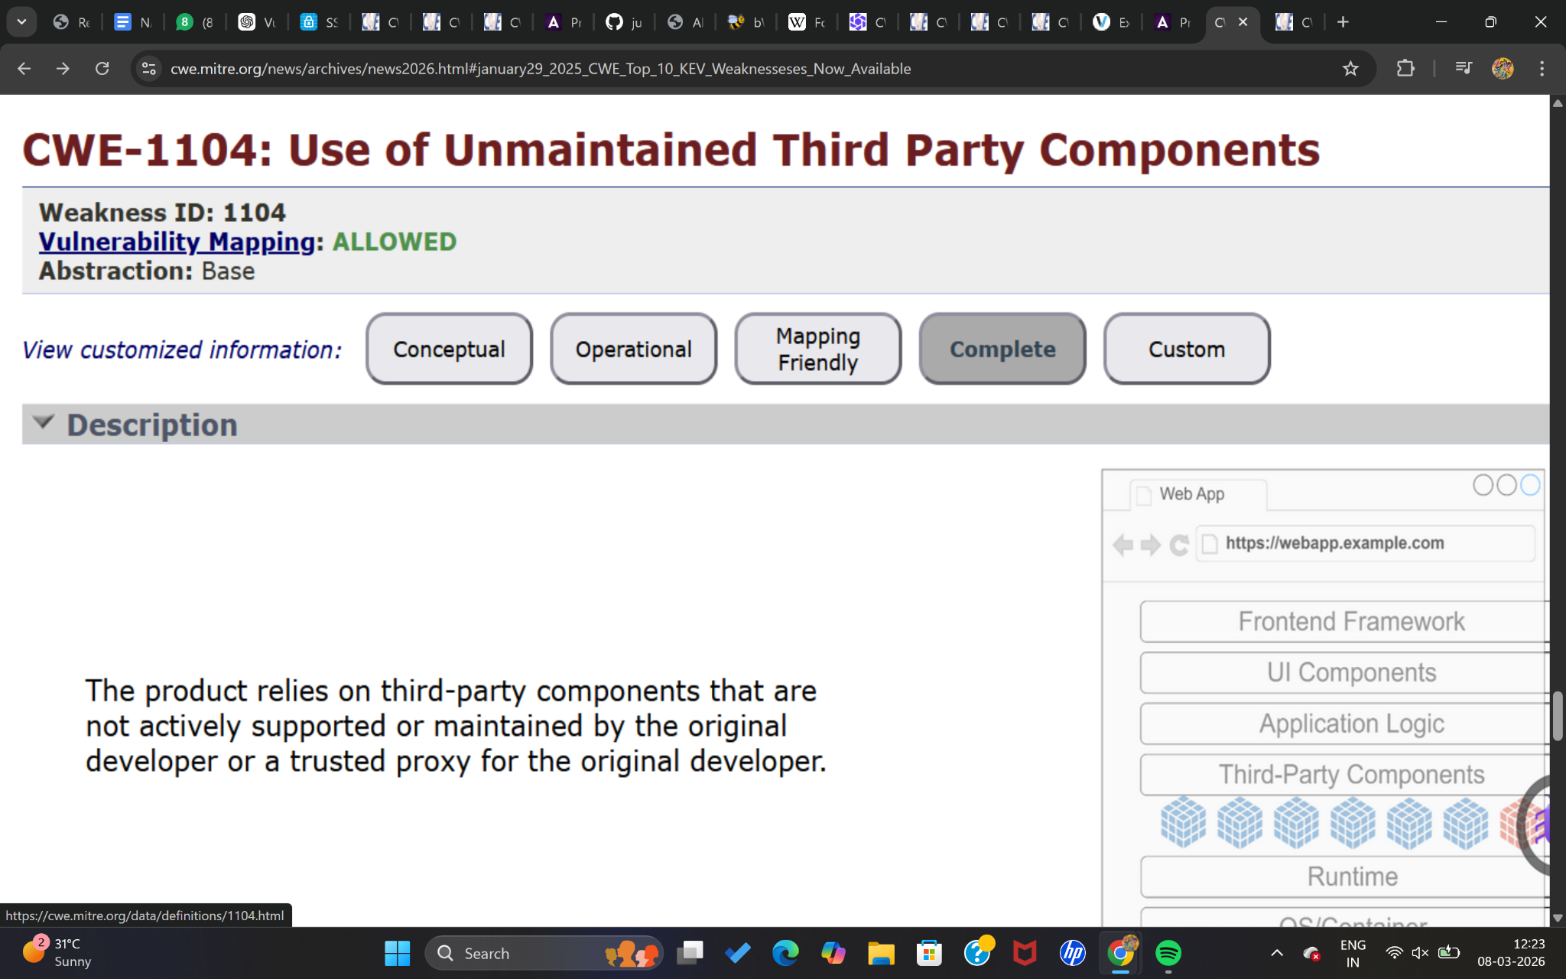

7) Vulnerability Name: Authentication Bypass by Capture-Replay
CWE: CWE – 294
OWASP Category: A07:2021 – Identification and Authentication Failures

Description
Authentication bypass by capture-replay occurs when attackers intercept authentication data such as session tokens or login requests and reuse them to gain unauthorized access.
In this attack, the attacker captures a legitimate authentication request and later replays the same request to impersonate the user.
This vulnerability commonly occurs when applications do not implement proper session validation, timestamp verification, or token expiration mechanisms.
For example, if authentication tokens remain valid indefinitely, attackers can reuse captured tokens to access accounts without knowing the user's password.
To prevent replay attacks, developers should implement secure session management techniques such as token expiration, nonce values, timestamps, and encrypted communication channels.

Business Impact
Unauthorized Account Access
Attackers may gain access to user accounts without knowing passwords.
Fraudulent Activities
Attackers may perform transactions or actions under the victim's identity.
Loss of Customer Trust
Users may lose confidence in the security of the system.
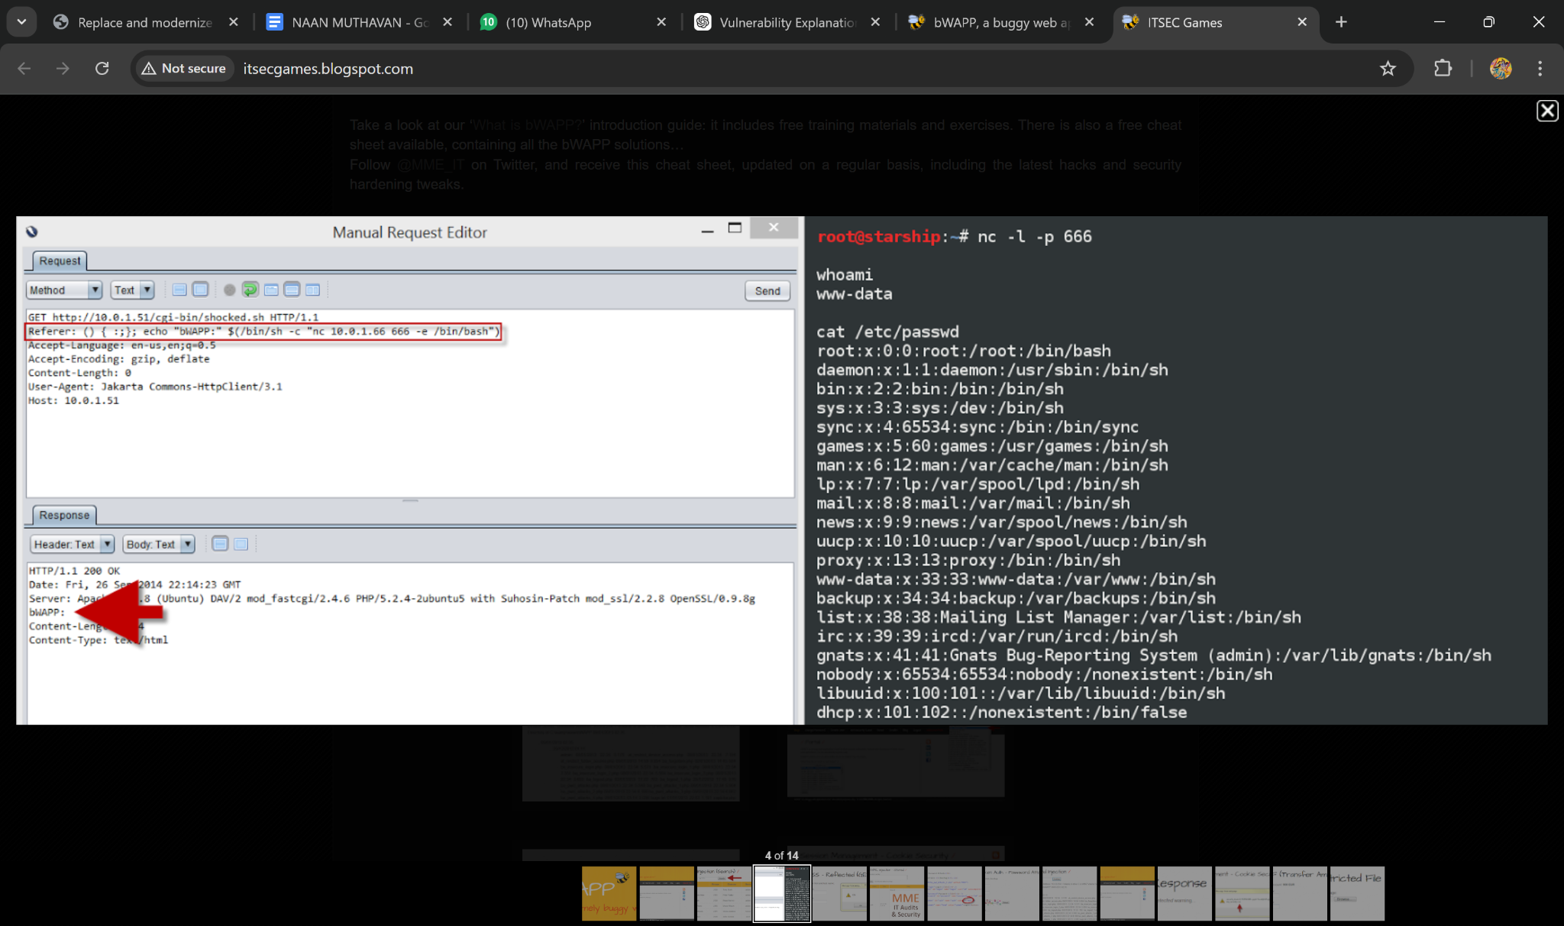

8) Vulnerability Name: Reliance on Cookies without Validation and Integrity Checking
CWE: CWE – 565
OWASP Category: A08:2021 – Software and Data Integrity Failures

Description
Many web applications rely on cookies to store user session information, preferences, or authentication tokens. However, if cookies are not validated or protected with integrity checks, attackers may manipulate them.
For example, attackers may modify cookie values to escalate privileges or impersonate other users. If the application blindly trusts the cookie without verifying its authenticity, unauthorized access may occur.
This vulnerability typically occurs when cookies are not signed, encrypted, or validated on the server side.
To mitigate this risk, developers should implement secure cookie attributes such as HttpOnly, Secure, and SameSite, and verify cookie integrity using cryptographic signing.

Business Impact
Session Hijacking
Attackers may hijack user sessions and gain unauthorized access.
Privilege Escalation
Attackers may modify cookie values to gain administrator privileges.
Data Theft
Unauthorized access may lead to sensitive data exposure.
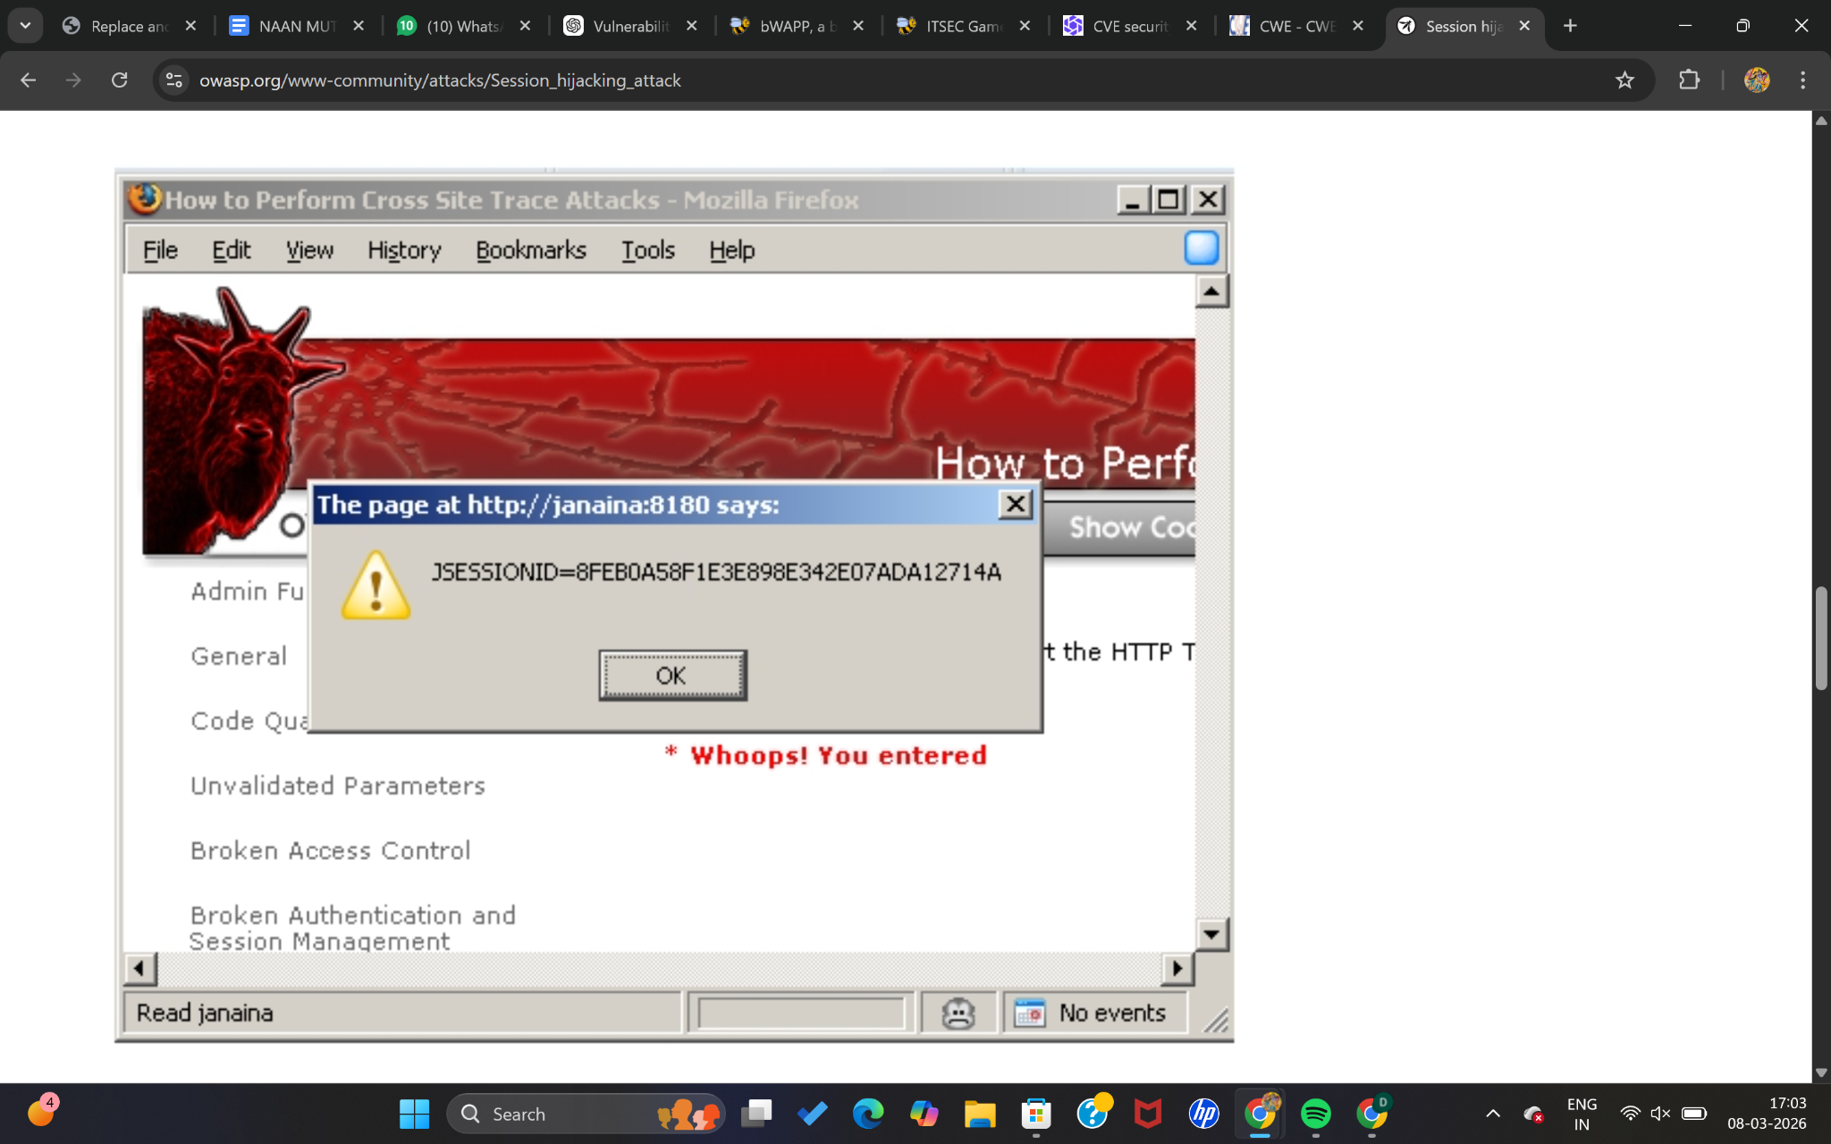

10) Vulnerability Name: Divide By Zero
CWE: CWE – 369
OWASP Category: A10:2021 – Server-Side Request Forgery / Mishandling of Exceptional Conditions

Description
Divide by zero is a software error that occurs when an application attempts to divide a number by zero during program execution.
This error can cause the application to crash, produce unexpected results, or expose system information through error messages.
Attackers may intentionally trigger this condition by providing input values that cause calculations to divide by zero. This can lead to denial of service or application instability.
To prevent this vulnerability, developers should implement proper input validation and error handling mechanisms to ensure that calculations do not attempt invalid mathematical operations.

Business Impact
Application Crash
Unexpected errors may cause the system or service to stop functioning.
Denial of Service
Attackers may repeatedly trigger the error to disrupt services.
Information Disclosure
Error messages may reveal system information useful for further attacks.
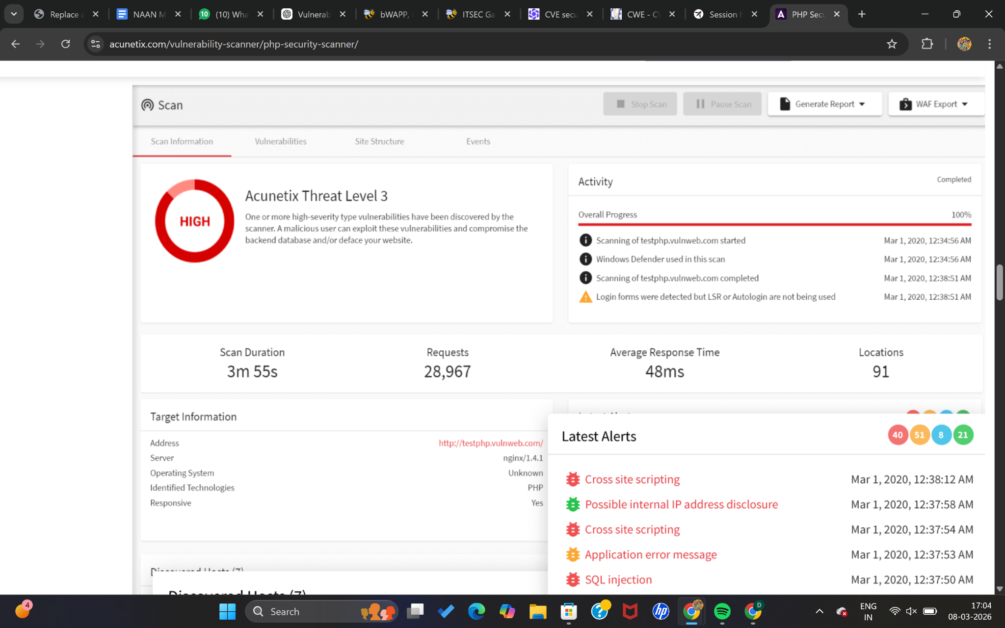

Stage 2

Overview :-

Legacy VPN architectures are used by organizations to provide secure remote access to internal networks. In this method, users connect to the company network through a VPN gateway which creates an encrypted tunnel between the user device and the corporate network. However, once connected, users often receive wide access to internal resources, which can increase security risks.

A cloud-native Zscaler Zero Trust solution modernizes this approach by providing secure access based on the Zero Trust principle, which means “never trust, always verify.”Instead of giving full network access, the system verifies the identity of users and devices before allowing access to specific applications.

Zscaler operates through a cloud-based platform that sits between users and applications. When a user tries to access an application, the request is sent to the Zscaler cloud where authentication and security checks are performed. The system evaluates policies and only allows access if the user meets the required security conditions.

The platform includes services such as Zscaler Internet Access (ZIA) and Zscaler Private Access (ZPA) to protect internet and private applications. It also monitors traffic, detects threats, and generates detailed reports for administrators.

By replacing traditional VPN with Zscaler Zero Trust architecture, organizations can improve security, reduce network risks, and provide faster and more secure access to applications for remote users.

Zscaler can be used to secure a variety of targets, including internal enterprise applications, cloud applications, remote users, and branch networks. It can also control access to specific applications and services based on defined security policies. Zscaler can be configured to monitor access continuously and generate security reports for administrators.

Here is a step-by-step explanation of how Zscaler Zero Trust works:

1. The user attempts to access an application through the Zscaler cloud platform.
2. Zscaler verifies the identity of the user using authentication systems such as Single Sign-On (SSO).
3. The platform checks device posture and evaluates security policies defined by the organization.
4. If all conditions are satisfied, Zscaler creates a secure connection between the user and the specific application.
5. Zscaler monitors the connection and generates reports that include user activity, detected threats, and recommended security actions.

Zscaler is a valuable solution for organizations that want to improve security and modernize their network infrastructure. It provides secure access to applications without exposing the internal network to external threats.

Here are some of the benefits of using Zscaler Zero Trust:

● Improved security: Access is granted only after verifying user identity, device health, and security policies.
● Cloud-based architecture: No need for traditional VPN hardware or network exposure.
● Comprehensive monitoring: Zscaler generates detailed reports about user access and security events.
● Scalability: It can support large numbers of users and applications across different locations.
● Flexibility:Security policies can be configured and updated easily through the cloud platform.

Zscaler Zero Trust is a powerful solution that improves network security. It is useful for organizations to protect their systems and data.

Target Website:- [http://testfire.net/](http://testfire.net/)
Target IP Address:- 65.61.137.117

List of vulnerability:-

S.no | Vulnerability Name | Severity | Plugin ID
1 | TLS Version 1.0 Protocol Detection | MEDIUM | 104743
2 | TLS Version 1.1 Protocol Deprecated | MEDIUM | 157288
3 | SSL/TLS Diffie-Hellman Modulus ≤1024 Bits (Logjam) | LOW | 83875
4 | ICMP Timestamp Request Remote Date Disclosure | INFO | 10114
5 | Additional DNS Hostnames | INFO | 46180
6 | Apache Tomcat Detection | INFO | 39446
7 | Common Platform Enumeration (CPE) | INFO | 45590
8 | Device Type | INFO | 54615
9 | HSTS Missing From HTTPS Server | INFO | 84502
10 | HTTP Server Type and Version | INFO | 10107

REPORT: -

1. Vulnerability:- TLS 1.0 Protocol Supported

Severity: - Medium

Plugin ID:- 104743

Port:- 443

Description:- The scanned service allows encrypted communication using TLS version 1.0. This protocol contains several cryptographic weaknesses that can expose secure communications to potential attacks. Although some modern implementations attempt to mitigate these weaknesses, TLS 1.0 is considered obsolete and insecure compared to newer standards such as TLS 1.2 and TLS 1.3.

Major web browsers and technology vendors discontinued support for TLS 1.0 starting March 31, 2020. In addition, PCI DSS v3.2 mandates that organizations completely disable TLS 1.0 except in specific legacy POS scenarios where compensating controls exist.

Solution:-

Disable TLS 1.0 support on the affected service and configure the server to accept only TLS 1.2 or TLS 1.3 connections.

Business Impact:-

Using an outdated encryption protocol increases the risk of data exposure and cyberattacks. Attackers may exploit TLS 1.0 weaknesses to intercept sensitive communications. Furthermore, continued use of this protocol may lead to compliance violations with PCI DSS standards, potentially resulting in penalties and reputational damage. Updating to modern TLS versions improves security and ensures compatibility with modern browsers and applications.

2. Vulnerability:- TLS 1.1 Protocol Deprecated

Severity:- Medium

Plugin ID:- 157288

Port:- 443

Description

The remote server supports TLS version 1.1, which is considered deprecated. TLS 1.1 does not support modern cryptographic algorithms or advanced cipher suites such as Authenticated Encryption with Galois/Counter Mode (GCM). This limitation reduces the strength of encrypted communications.

Major browsers and vendors have also deprecated TLS 1.1 since March 2020, requiring servers to adopt TLS 1.2 or later for secure communications.

Solution:-

Disable TLS 1.1 on the server and ensure that only TLS 1.2 and TLS 1.3 protocols are enabled for secure communication.

Business Impact:-

The continued use of TLS 1.1 weakens the organization’s security posture and increases exposure to potential cryptographic attacks. In addition, systems that rely on outdated TLS versions may experience compatibility issues with modern browsers and external services. Remediating this issue helps maintain secure communications and ensures continued compatibility with modern technologies.

3. Vulnerability:- Weak Diffie-Hellman Key Exchange (Logjam)

Severity:- Low

Plugin ID:- 83875

Port:- 443

Description:-

The server allows **Diffie-Hellman key exchange parameters with a modulus size of 1024 bits or less**. Such weak parameters are susceptible to cryptographic attacks, including the **Logjam attack**, which can allow an attacker to compromise the encryption key used during secure communications.

If an attacker successfully breaks the key exchange, they may be able to decrypt sensitive data or manipulate the integrity of secure sessions.

Solution:-

Reconfigure the server to use strong Diffie-Hellman parameters, preferably 2048-bit or higher, and disable weak cipher suites that rely on small DH moduli.

Business Impact:-

Weak key exchange parameters may allow attackers with sufficient computational resources to compromise encrypted communications. Although the likelihood may be relatively low, successful exploitation could result in the exposure of sensitive information or compromised communication integrity. Strengthening cryptographic parameters reduces this risk and improves overall encryption security.

4. Vulnerability: ICMP Timestamp Request Enabled

Plugin ID:- 10114
Severity:- Informational
Port:- 0

Description

The target system responds to ICMP timestamp requests, allowing external systems to retrieve the system's current time information. This behavior may provide attackers with system timing details that could assist in reconnaissance or in bypassing certain time-based authentication mechanisms.

Solution:-

Block ICMP timestamp request (Type 13) and ICMP timestamp reply (Type 14) packets at the network firewall or host-based firewall.

Business Impact

While this vulnerability does not directly compromise the system, it may provide useful information to attackers performing reconnaissance. Restricting this response reduces unnecessary information disclosure and improves the overall security posture.

5. Vulnerability: Additional DNS Hostnames Detected

Plugin ID: 46180
Severity: Informational
Port: 0

Description

The scan identified multiple DNS hostnames associated with the target system. These hostnames may represent additional domains or virtual hosts configured on the same web server.

Solution

Review the discovered hostnames and ensure they are properly documented and secured. If required, perform additional scans using virtual host (vhost) syntax to evaluate each hostname individually.

Business Impact

This finding does not represent a direct security vulnerability. However, identifying additional hostnames can help administrators understand server configurations and detect potentially undocumented services or domains.

6. Vulnerability: Apache Tomcat Server Detected

Plugin ID: 39446
Severity: Informational
Port: 80

Description

The scanning tool identified the presence of an Apache Tomcat web server running on the remote host. This information is gathered through service detection techniques.

Solution

No direct remediation is required. However, administrators should ensure the Apache Tomcat server is fully patched and securely configured.

Business Impact

Although this finding is informational, revealing the presence of specific server technologies can provide useful intelligence to attackers. Maintaining updated software and restricting unnecessary information exposure helps minimize potential risks.

7. Vulnerability: Common Platform Enumeration (CPE) Identified

Plugin ID: 45590
Severity: Informational
Port:0

Description

The vulnerability scanner identified CPE identifiers related to hardware and software detected on the host. CPE is a standardized naming system used to identify technology products and components.

Solution

No action is required. Administrators may use this information for asset management and vulnerability tracking.

Business Impact

This information helps organizations maintain an accurate inventory of systems and software components. Proper asset visibility improves vulnerability management and security monitoring processes.

8. Vulnerability: Device Type Identification

Plugin ID: 54615
Severity: Informational
Port:0

Description

Based on operating system characteristics and service responses, the scanner was able to determine the type of device running on the remote host, such as a server, router, or workstation.

Solution

No remediation is required.

Business Impact

Device identification assists administrators in maintaining visibility of network assets. Proper classification of devices helps improve network monitoring, asset management, and security policy enforcement.

9. Vulnerability: HSTS Header Missing

Plugin ID: 84502
Severity: Informational
Port: 443

Description

The HTTPS server does not implement HTTP Strict Transport Security (HSTS). HSTS is a security mechanism that forces web browsers to communicate with the server exclusively over HTTPS.

Without HSTS, users may be vulnerable to downgrade attacks or SSL stripping, where attackers attempt to force insecure HTTP connections.

Solution

Configure the web server to include the HSTS response header in HTTPS responses.

Example:

Strict-Transport-Security: max-age=31536000; includeSubDomains

Business Impact

Without HSTS, attackers may attempt to intercept communications by forcing users to access the website over HTTP. Enabling HSTS ensures that browsers always use encrypted HTTPS connections, thereby improving data confidentiality and protection against man-in-the-middle attacks.

10. Vulnerability: HTTP Server Type and Version Disclosure

Plugin ID:10107
Severity:Informational
Port: 443

Description

The scan detected information about the web server type and version running on the host. This information is typically revealed through HTTP response headers.

Solution

Configure the web server to hide or minimize version information in HTTP headers.

Business Impact

Although this issue does not directly compromise security, disclosing server version details may assist attackers in identifying known vulnerabilities associated with that software. Limiting such information reduces the attack surface and enhances security.

If you want, I can also help you make this into a proper cybersecurity report format (like for internship/project submission with sections like Executive Summary, Risk Rating Table, and Conclusion) which usually gives higher marks in academic projects.
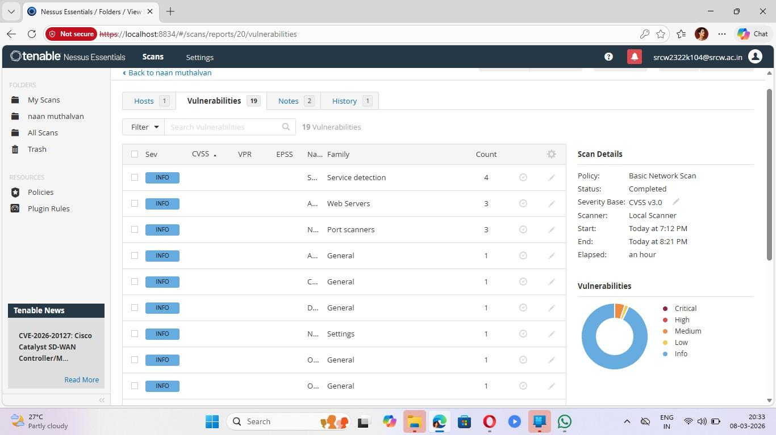

Explanation of Nessus Scan Vulnerabilities

1. Service Detection
Severity: Info
Count: 4

Explanation
Service detection means the scanner has identified services running on the target machine. These services may include:
- Web servers
- SSH services
- FTP services
- Database services
Nessus performs service detection to determine which applications and services are active on specific ports.

Why this matters
Attackers often scan networks to discover services and their versions. If an outdated or vulnerable service is detected, it could be exploited.

Example
If a web server is running on port 80 or 443, attackers may attempt:
- Web application attacks
- Server exploitation
- Configuration bypass attacks

2. Web Servers
Severity: Info
Count: 3

Explanation
This indicates that Nessus detected web server software running on the target system.
Examples of web servers include:
- Apache
- Nginx
- IIS
The scanner gathers information such as:
- Web server type
- Server version
- Response headers

Why this matters
Web servers are one of the most common attack targets. Misconfigurations or outdated versions can lead to vulnerabilities such as:
- Cross-Site Scripting (XSS)
- SQL Injection
- Directory traversal
- Server misconfiguration

3. Port Scanners Detection
Severity: Info
Count: 3

Explanation
This entry indicates that open ports were discovered during the scan.
Ports are communication endpoints used by services.
Example ports:
Port | Service
80 | HTTP
443 | HTTPS
22 | SSH
21 | FTP

Why this matters
Open ports increase the attack surface. Attackers use tools like:
- Nmap
- Masscan
to discover open ports and attempt exploitation.

4. General Information
Severity: Info

Explanation
General vulnerabilities contain informational findings about the system configuration.
Examples include:
- Host name detection
- System banner information
- Operating system fingerprinting
- Network configuration data

Why this matters
Attackers often perform information gathering (reconnaissance) before launching attacks.

5. Configuration Information
Severity: Info

Explanation
Configuration vulnerabilities identify system configuration details such as:
- Enabled protocols
- Security settings
- Default configurations
Misconfigurations can lead to security risks if not properly secured.

6. Nessus Settings Information
Severity: Info

Explanation
These findings describe the scanner configuration and environment.
Examples include:
- Scan policy used
- Plugins executed
- Network discovery results
These are mainly informational and help administrators understand the scan results.

Vulnerability Summary (From the Chart)
The pie chart on the right shows the severity distribution:
Severity | Meaning
Critical | Very dangerous vulnerability
High | Serious vulnerability
Medium | Moderate security risk
Low | Minor issue
Info | Informational only
In your scan:
- Most findings are Info
- Very few Low or Medium issues
- No Critical vulnerabilities
This means the system is relatively safe, but the scan mainly discovered system information and service details.

What This Means for Your Project (Stage 2 – Vulnerability Assessment)
You can write in your report:
- Nessus was used to perform a Basic Network Scan.
- The scan detected 19 vulnerabilities, mostly informational.
- These findings provide insight into services, ports, and configurations of the target system.
- Even informational findings are important because attackers can use this information during reconnaissance phases.

STAGE 3

REPORT

Title: Replace and modernize legacy VPN architectures with a cloud-native Zscaler Zero Trust solution

1. Introduction to Legacy VPN Architecture

Traditional Virtual Private Network (VPN) architectures have long been used by organizations to provide secure remote access to internal corporate networks. In a legacy VPN model, employees working outside the office connect to the organization’s internal network through a centralized VPN gateway. The VPN gateway authenticates the user and creates an encrypted communication tunnel between the user's device and the corporate network.

Once authenticated, the user is granted access to the organization's internal network resources such as databases, file servers, internal applications, and communication systems. This method was widely adopted because it provided secure connectivity for employees working remotely or traveling.

However, modern business environments have significantly evolved. Organizations now rely heavily on:

Cloud computing platforms

Software-as-a-Service (SaaS) applications

Remote and hybrid work environments

Mobile devices and distributed workforces

Because of these changes, traditional VPN architectures are becoming inefficient, complex, and difficult to manage.

One major limitation of legacy VPN architecture is that it follows a network-centric security model. Once a user is authenticated, they often receive access to large portions of the corporate network instead of only the applications they require. This excessive access increases the risk of:

Unauthorized access to sensitive systems

Lateral movement by attackers

Data breaches and internal threats

Additionally, legacy VPN infrastructures depend on hardware appliances installed in data centers. These appliances require continuous maintenance, hardware upgrades, and manual configuration. During periods of high usage, such as large-scale remote work adoption, VPN gateways may experience performance bottlenecks, congestion, and scalability challenges.

Therefore, organizations are increasingly shifting toward modern cloud-based security architectures that provide stronger access control, better performance, and improved scalability.

2. Limitations of Traditional VPN-Based Security

Although VPNs provide encrypted communication between remote users and corporate networks, they present several security, operational, and performance limitations.

1. Implicit Trust Model

Traditional VPN systems operate on an implicit trust model. Once a user successfully authenticates to the VPN gateway, the network assumes that the user and device are trustworthy.

However, modern cybersecurity frameworks emphasize continuous verification rather than one-time authentication. Attackers who obtain valid credentials can easily gain access to internal networks through VPN connections.

2. Excessive Network Access
VPN connections provide network-level access, meaning users often gain access to entire network segments rather than only the applications they require. This increases the risk of lateral movement, where attackers can move between systems once inside the network.

3. Network Congestion and Traffic Backhauling

In traditional VPN architectures, user traffic is routed through the corporate data center before reaching cloud applications. This process is known as traffic backhauling.

This results in:

Increased latency

Slower application performance

Poor user experience

For organizations that rely on cloud applications like Microsoft 365 or Google Workspace, this routing method significantly reduces efficiency.

4. Scalability Challenges

VPN infrastructures depend on physical hardware appliances that must be manually scaled. When organizations suddenly need to support thousands of remote users, they must invest in additional hardware, configure new gateways, and upgrade bandwidth capacity.

This process is expensive, time-consuming, and operationally complex.

5. Limited Visibility and Monitoring

Legacy VPN systems provide limited visibility into:

User activity

Application access patterns

Device security posture

This lack of visibility makes it difficult for security teams to detect suspicious behavior or potential security threats.

Due to these limitations, organizations are increasingly adopting Zero Trust security frameworks that provide stronger protection and improved operational efficiency.

3. Concept of Zero Trust Security Model

The Zero Trust Security Model is a modern cybersecurity framework designed to eliminate the assumption that users inside the corporate network are automatically trusted.

Instead of trusting users based on network location, Zero Trust follows the principle:

“Never Trust, Always Verify.”

In a Zero Trust architecture, every user, device, and application must be authenticated and authorized before access is granted. Security decisions are based on multiple contextual factors.

Key Verification Factors

Access requests are evaluated based on:

User Identity – verifying the user through authentication methods such as MFA

Device Security Posture – ensuring the device meets security requirements

Location of Access – evaluating geographic location and network environment

Application Sensitivity – determining the importance of the requested resource

Behavioral Patterns – detecting abnormal or suspicious activity

Principle of Least Privilege

Zero Trust enforces the principle of least privilege, meaning users are granted access only to the specific applications or resources required for their job.

Micro-Segmentation

Applications and services are segmented to prevent attackers from moving laterally within the network.

Continuous Monitoring

User sessions are continuously monitored. If suspicious behavior is detected, access can be automatically restricted or terminated.

By implementing these principles, Zero Trust architectures significantly reduce the risk of:

Insider threats

Credential theft

Malware propagation

Unauthorized data access

4. Overview of Zscaler Cloud-Native Security Platform

Zscaler is a leading cloud-native cybersecurity platform designed to support Zero Trust network access for modern enterprises.

Unlike traditional security systems that rely on on-premise hardware, Zscaler operates entirely through a globally distributed cloud security platform.

The platform acts as a secure intermediary between users and applications, ensuring that all connections are authenticated, inspected, and protected.

Key Zscaler Services
Zscaler Internet Access (ZIA)

ZIA provides secure access to internet and SaaS applications. It performs:

Web filtering

Malware protection

SSL inspection

Data loss prevention

Zscaler Private Access (ZPA)

ZPA enables secure access to internal enterprise applications without exposing them to the public internet.

Instead of connecting users to the network, ZPA connects users directly to applications through secure connections.

Key Advantages of Zscaler Platform

Cloud-native architecture

Global security infrastructure

High scalability

Centralized management

Real-time threat detection

Because Zscaler operates through the cloud, organizations can secure users, applications, and devices regardless of location.

5. Architecture of Zscaler Zero Trust Implementation

The Zscaler Zero Trust architecture replaces traditional VPN gateways with a cloud-based secure access framework.

In this model, users do not connect directly to the corporate network. Instead, they connect to the Zscaler cloud platform, which securely brokers connections between users and applications.

Key Components of Zscaler Architecture

1. User Device

The endpoint device used by employees to access corporate applications. This may include laptops, desktops, tablets, or mobile devices.

2. Zscaler Client Connector

A lightweight software agent installed on the user device. It establishes secure connections with the Zscaler cloud platform and enforces security policies.

3. Zscaler Cloud Security Platform

The central security infrastructure that performs:

Authentication and authorization

Traffic inspection

Security policy enforcement
Threat detection

4. Application Connectors

These connectors are deployed near enterprise applications located in data centers or cloud environments. They create secure outbound connections to the Zscaler cloud without exposing applications to the internet.

Security Advantages

Applications remain invisible to the public internet

Attack surface is significantly reduced

Unauthorized access attempts are blocked before reaching internal systems

6. Benefits of Replacing VPN with Zscaler Zero Trust

Modernizing legacy VPN systems with a Zscaler Zero Trust architecture provides multiple security and operational advantages.

1. Improved Security

Users gain access only to specific applications instead of the entire network. This prevents attackers from moving laterally within the network.

2. Reduced Attack Surface

Internal applications are hidden behind the Zscaler cloud platform and are not directly exposed to the internet.

3. Better User Experience

Users connect to the nearest Zscaler data center, reducing latency and improving application performance.

4. Simplified Network Management

Organizations no longer need to maintain multiple VPN appliances or complex firewall configurations.

5. Automatic Scalability

Zscaler’s cloud infrastructure can automatically scale to support large numbers of users without requiring hardware upgrades.

6. Centralized Security Policies

Security administrators can manage all policies from a centralized platform, simplifying monitoring and policy enforcement.

7. Future Scope and Conclusion

As organizations increasingly adopt cloud services, remote work models, and digital transformation strategies, traditional network-based security models are becoming obsolete.

The transition from legacy VPN architectures to a Zero Trust framework powered by Zscaler represents a major advancement in enterprise cybersecurity.

By implementing Zscaler’s cloud-native security platform, organizations can achieve:

Stronger access control

Reduced attack surfaces

Improved scalability

Better user experience

Zero Trust ensures that security policies are continuously enforced regardless of where users or applications are located.

This modern architecture enables organizations to build secure, scalable, and resilient network infrastructures capable of addressing both current and future cybersecurity challenges.

Topics Explored

Legacy VPN Architecture

VPN Security Vulnerabilities

Zero Trust Security Model

Zscaler Zero Trust Exchange

Zscaler Private Access (ZPA)

Vulnerability Assessment

Common Web Security Vulnerabilities (CWE)

Authentication and Access Control

Network Security Monitoring

Cloud-Native Security Solutions

Tools Explored

Zscaler Zero Trust Exchange

Zscaler Private Access (ZPA)

Nessus Vulnerability Scanner

Vulnerability Practice Websites

